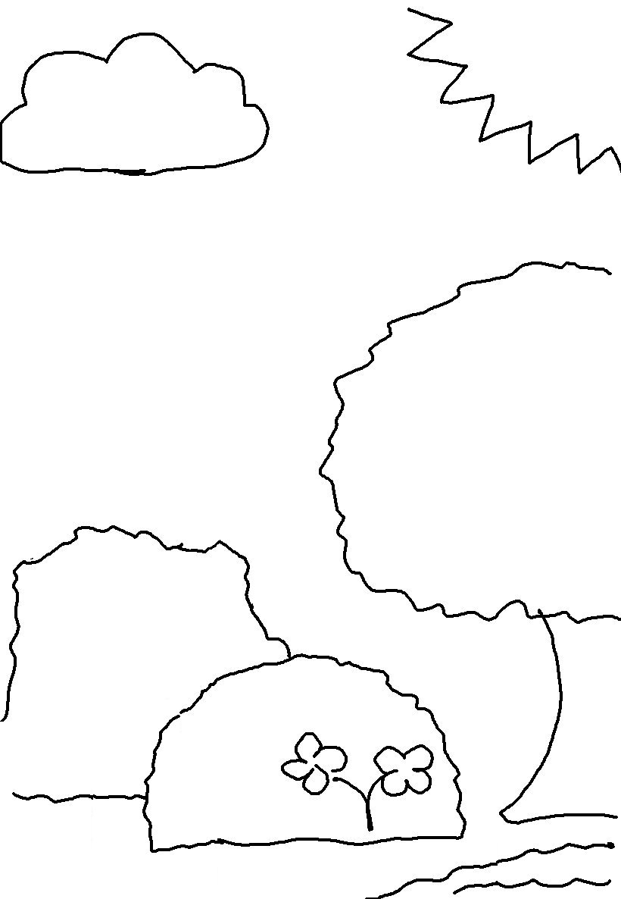
In the beginning God created the heavens and the earth. Genesis 1:1

